**SQL Implementation Screenshots**

RESULT_ANALYSIS with probability:

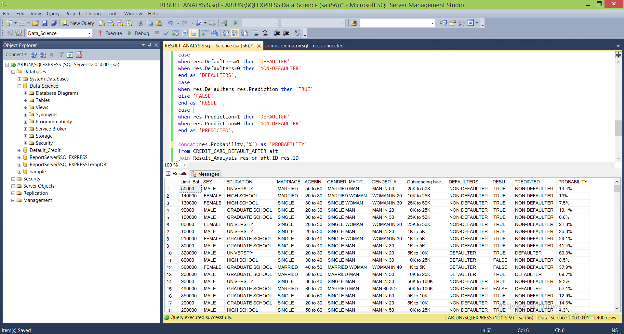

Confusion matrix implementation:

